UNIT/01: RELATIONSHIPS
READING
IN THIS unIT YOU WILL
LEARN HOW TO
- answer questions using up to three words
- identify key words in a question
- scan a text to find specific information.

Lead-in

 | In pairs, explain the words in the box.  Example: sister: My sister is my parents' daughter / other daughter.  brother : My brother is my parents' son.  cousin : My cousin is my aunt or uncle's son or daughter.  father-in-law: My father-in-law is my husband or wife's father.  grandfather : My grandfather is my mother or father's father.  uncle : My uncle is my mother or father's brother.  aunt : My aunt is my mother or father's sister.  nephew : My nephew is my brother or sister's son.  niece : My niece is my brother or sister's daughter.  great-aunt : My great-aunt is my grandmother or grandfather's sister.  grandmother : My grandmother is my mother or father's mother.  Tell your partner who you live with. Which other family members are you close to?
  01
  sister | brother | cousin | father-in-law | grandfather | uncle
  aunt | nephew | niece | great-aunt | grandmother

 | You are going to read about some advantages of living in an extended family (i.e. not just parents and children living together). Which of the following advantages do you think are the most important?  2, 3, 4 and 5 are mentioned in the text.  - Older people are fun to live with.  - Older people are patient and experienced.  - You can save money by living together.  - Grandparents are not as busy as parents.  - Children get plenty of love and attention.  Read the text quickly and check which are mentioned. Ignore the highlighted words.  TIP 02 | - Blood is thicker than water. This means that family is more important than anyone else. Many young people, though, spend more time with their friends than with their family. They value their friends' opinions more and enjoy their company. When it's time to visit grandma or go to a cousin's wedding, teenagers often prefer to be left at home. But are they missing out?  - In Asia, the Middle East, South America and Sub-Saharan Africa over 40% of children live in families with other adults such as aunts, uncles and grandparents in addition to their parents. In South Africa, it is almost 70%. On the other hand, in Europe, Australia and North America, less than 25% of children live in extended families. Is the lack of close contact with relatives putting some children at a disadvantage?
  02
  Don't worry if you don't know a word in the text. You can often guess the meaning by reading the other words in the sentence. And you may not need to know the meaning to answer the questions.
  BLOOD IS THICKER THAN WATER

- The people they live with have a great influence on the way children grow up. Those who live with their extended family have many advantages. They usually get lots of love and attention. Grandparents often have more time to read to children and play with them. As they are often retired, they are not always busy and stressed as many parents are. They have learnt to be patient and they have already handled most of the problems children and young people face. | - Young people whose grandparents live far away can gain some of these advantages by keeping in close contact by phone, email, letters and visits. It is nice to know there is someone you can go to if you have a problem. As the Italian proverb says, 'Se non sta andando bene chiamare la nonna.'- 'If things aren't going well, call your grandmother."
- It is good for children to grow up to understand the needs of older people: they may become more caring and less selfish if they spend time helping their grandparents. Children learn about the past from grandparents' stories. Sometimes they feel closer to their grandparents than to their parents. | - Friends are important to young people, but friends come and go. Your family is always on your side. Grandparents won't be there forever. Appreciate them while you can.
- Young adults often feel that living alone will be exciting, but they forget that it can also be lonely. By remaining with the family during this stage of their lives, they can avoid this. They can also save money for their education and future.

VOCABULARY

 | Match the highlighted words from the text with their meanings. Start with words you already know. Use the context (the sentence it is in and other words around it) to work out the meaning of the other words.
  03
  - value h  - (have an) influence g  - stressed a  - handled b  - selfish f  - gain c  - proverb e  - appreciate d | - worried; not able to relax  - dealt with, had experience of  - get (something positive)  - be grateful for  - a well-known phrase giving advice  - caring only about yourself and not other people  - (have an) effect (on)  - believe something is important
[[[[[[[[[[SHORT-ANSWER QUESTIONS]
FINDING INFORMATION
 | To practise finding information quickly, have a race with your partner to find the following phrases in the text. They are not in order.  To find information quickly, don't read every word. Don't try to say the words. Move your eyes quickly across and down the text. Use your finger if you find it useful.  How did you do this? Can you explain to another student how to find information quickly?
  04
  - grandparents' stories  paragraph D  - cousin's wedding  paragraph A  - young adults  paragraph E | - extended family  paragraph B  - come and go  paragraph G  - Italian proverb  paragraph F
  ◉ In this type of task you have to answer questions using up to three words, or up to two words and/or a number. The instructions tell you how many words you can use. Short-answer questions test if you can find the right part of the text quickly and understand the information.

IDENTIFYING THE KEY WORDS IN A QUESTION

 | Identify the key words in these questions.  - What percentage of children live in extended families in Asia, the Middle East, South America and Sub-Saharan Africa?  percentage/children/ extended families / Asia, the Middle East, South America, Sub-Saharan Africa  - Why are grandparents often less busy and stressed than parents?  grandparents/less busy/stressed/parents  - What do young adults often think living alone will be like?  young adults/think/living alone
  05
  ◉ Before you look for the answer to a question, it helps if you find the key words - the most important words - in the question. This will help you find the information you need.
  Example: What do young people often think about older family members?

SCANNING A TEXT
 | Answer the questions in exercise 5. Follow the advice in the box.  - over 40%  - They are often retired.  - (They think it will be) exciting.
  06
  ◉ When you are answering a question:
  - Decide on the key words in the question and think of words with a similar meaning.
  - Move your eyes quickly across and down the text, looking for the key words, or words that mean the same. Don't read every word. This is called 'scanning'
  - If the text has headings, use them to help you decide which part of the text to look at first.
  - When you find a key word, read the text around it to make sure you have found the right information.
 | Read this exam task and the answers to the questions. What is wrong with the answers? Match the answers 1-4 with the advice a-d below.  Answer these questions. Choose NO MORE THAN TWO WORDS AND/OR A NUMBER from the passage for each answer.  - b  - d  - a  - c  Question 1 What percentage of children in South Africa live with their extended family?  Answer 1: 20%  Question 2 What helps children in extended families learn about the past?  Answer 2: grandparents storys  Question 3 What negative word can describe how it sometimes feels to live alone?  Answer 3: Living alone can be lonely.  Question 4 According to the Italian proverb, who should you phone when you have a problem?  Answer 4: your gran  - Don't write more than the number of words you are given.  You mustn't write full sentences.  - Make sure that you use the correct information when you answer a question.  - Don't change words in the text. Remember, the instructions tell you to choose words from the text.  - Be careful with spelling. You can lose marks if your spelling is wrong. | TIP 07
  07
  Some grammar words (e.g. a, the, some) can be omitted in order to get the right number of words.
 | Now correct the answers in exercise 7.  - over 40%  - grandparents' stories  - lonely  - your grandmother
  08

GRAMMAR FOCUS: TENSES
 | Answer these questions.  - What tense are most of the verbs in the text?  present simple  - Choose the correct reason for the choice of tense.  b  - The verbs describe events which are happening now.  - The verbs describe things that are generally true.  - The verbs give the writer's opinion.
  09

GRAMMAR FOCUS: ADVERBS OF FREQUENCY
 | Identify the frequency adverbs in these sentences from the text.  - Your family is always on your side.  always  - Teenagers often prefer to be left at home.  often  - As they are often retired, they are not always busy...  often; (not) always  - They usually get lots of love and attention.  usually  - Sometimes they feel closer to their grandparents than to their parents.  Sometimes
  10
  ◉ Grandparents often have more time to read to children.
  Often is an adverb of frequency. It gives us an idea of how often something happens. The present simple tells us about regular events, and adverbs of frequency are common with this tense.
 | Study the position of the frequency adverbs in the sentences in exercise 10. With a partner, work out some rules on the position of frequency adverbs.  The frequency adverb is usually between the subject and the verb. (I often cook). When the verb is 'to be', the adverb comes after the verb. (It is always cold.) Some frequency adverbs can also start a sentence. (Sometimes I watch TV.)
  11
[[[[[[[[[[EXAM SKILLS]
 | Read the passage and answer the questions below.
  12
SOCIAL MEDIA AND THE MEANING OF FRIENDSHIP
There have been a lot of scientific studies into what makes a friendship. It seems today that ideas of what friendship is are also changing. A study in 1993 at the University of Oxford showed that people could only maintain 150 relationships. However, with the explosion of social media since then, many people now have over 300 people who they think of as friends. Some people think that these friends are not real friends, but others believe that social media has helped us to expand and keep our friendships because we have more time and opportunities.  Another change from the past is that people don't stay in the place where they were born. They go to different cities and countries for education and jobs. People are in general more geographically mobile nowadays. This means that we have more chances to meet and make friends with people from different cultures and different backgrounds. People still often make friends at college who remain friends for life, but | making new friends at work is more difficult. People now have less security at work and this also means that they find it harder to build new relationships.  As people get older, they sometimes also have less free time. They become busier with their jobs and families and have less time to spend with friends. Friendships can be very different when we are at different ages. Young children often choose their friends because of convenience, for example, they go to the same school, they live near each other or their parents are friends. As we get older, friendships are more connected with having similar interests and opinions.  One thing is definitely true though, it doesn't matter how old we are or how many friends we have on social media, friendship is good for our health. People who spend time with friends have fewer mental health problems and are generally happier and in a better physical state of health than people who spend their free time alone.

Answer the questions below. Choose NO MORE THAN THREE WORDS from the passage foreach answer.
- What has enabled people to have more friends than in the past, according to some people?
social media
- What phrase does the writer use to describe people who don't stay in the same place?
geographically mobile
- What work-related problem do people have that makes them less likely to form friendships?
less security
- What frequently influences the friendships of young children?
convenience
- What are people with friends less likely to suffer from?
mental health problems

UNIT/01: RELATIONSHIPS
WRITING
IN THIS unIT YOU WILL
LEARN HOW TO
- describe a process (Writing Part 1)
- use sequencing expressions to describe the order of stages in a process
- use the present simple passive to describe a process
- write an introduction and overview.

Lead-in

 | What foods do you eat at a family celebration? Do you know how to prepare them? Do you need any special equipment?
  01
 | In Sri Lanka, a family meal often includes stringhoppers. To make stringhoppers you need some special equipment. Choose the best description of each piece of equipment. |  | 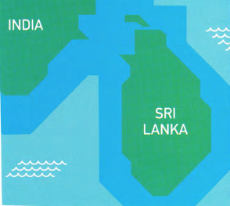
  02
  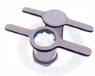 | - Stringhopper press B  - It has two parts which are different in shape but the same size. It is made of a light material such as plastic.  - It's made of heavy metal and has two parts which are similar in shape. The centre is round and there are handles on each side. One part fits into the other.  - It has two parts and one goes on top of the other. It is square in shape and made of wood.
  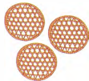 | - Stringhopper mats A  - These are round shallow baskets made of thin pieces of wood. The wood is in a criss-cross pattern to form large holes.  - These are cloth triangles with very small holes in them.  - These are thick pieces of wood with rectangular holes in them.
  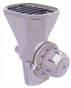 | - Stringhopper mats C  - It is made of metal and the top and bottom are the same size and shape.  - It is a metal machine with a wide base and a narrow tray on top.  - It is a machine made of metal with a wide tray at the top and a narrower base.

 | Complete the chart with words from exercise 2.
  03
  Materials | Parts | Shapes
  Plastic  metal  wood  cloth | Handles  base  tray | round  square  triangle  rectangular

[[[[[[[[[[PART 1: DESCRIBING A PROCESS]
 | The pictures show the process of making stringhoppers.  Match the short instructions to the pictures.  - c  - b  - f  - a  - d  - e |  |  |  | TIP 04
  04
  Don't worry if you don't know a word in the text. You can often guess the meaning by reading the other words in the sentence. And you may not need to know the meaning to answer the questions.
 | 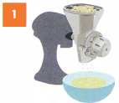 | 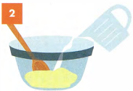 |  | 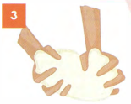
 | 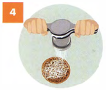 | 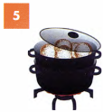 |  | 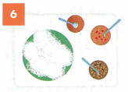
 | - push through the stringhopper press onto the stringhopper mats  - add water to the flour  - put the rice into the grinder and grind into flour  - cook in a steamer  - serve with spicy curries  - mix well to form a dough
  ◉ We use the present simple passive to describe a process.
  We make them with rice. → They are made with rice.
  You mix it with water. → It is mixed with water.

GRAMMAR FOCUS: THE PRESENT SIMPLE PASSIVE

 | Complete the sentences about tea. Use the verbs in brackets in the present simple passive.  Tea leaves are picked(pick) by hand.  Only the best leaves are used(use).  A lot of water is needed(need) to grow tea plants successfully.  A lot of tea is grown(grow) in China and India.
  05

GRAMMAR FOCUS: SEQUENCING WORDS

 | Complete the sentences about making stringhoppers with words from the box.  - First, the rice is put through a grinder.  - After that, water is added to the flour.  - Then/ Next it is mixed and made into a dough.  - The next stage is to push the dough through the stringhopper press.  - Next I Then the stringhoppers are placed in a steamer.  - Finally, they are served with spicy curries. | TIP 06
  06
  After | Finally | First | Next | The next stage | Then
  When describing the stages in a process, it is important to use sequencing expressions, for example first, then, next, to clearly show the order of the stages.

WRITING AN INTRODUCTION AND OVERVIEW

 | Which of these is an introduction and which is an overview?  - There are six stages in the process of making stringhoppers, beginning with grinding the rice and making a dough and ending with using a steamer to cook the stringhoppers.  overview  - The diagram demonstrates the process of preparing stringhoppers, a kind of noodle.  introduction
  07
  ◉ In Writing Task 1 your answer should include an introduction and an overview. The introduction is usually the task question rewritten in your own words. The overview is a summary of the process.
 | Which of these are NOT overviews?  a and d are not overviews  - The process of making blue cheese can be seen in this series of pictures.  - To make a perfect omelette you need fresh ingredients, the right equipment and the correct technique. You must also cook it for the correct amount of time and pay attention to the temperature.  - The production of tea involves a range of stages, from picking the leaves from the plant to drying and distributing it.  - The diagram shows the various stages in the process of making strawberry jam.  The first stage is to pick the strawberries when they are ripe.
  08

STUDYING A MODEL ANSWER

 | Study the essay opposite and find:  - the introduction  The diagram demonstrates the process of preparing stringhoppers, a kind of noodle dish.  - the overview  There are six main stages in the process, beginning with grinding the rice and making a dough and ending with using a steamer to cook the stringhoppers.  - sequencing expressions  First, Next, After that, then, The final stage is  - verbs in the present simple passive  is put, is mixed, (is) formed, is put, is pushed, are placed, are... cooked  - descriptions of the equipment  a metal piece of equipment with two handles and holes in it; round baskets made of thin pieces of wood  - vocabulary from the short instructions  grind, rice, dough, steamer, grinder, flour, stringhopper press, stringhopper mats, cook, serve, spicy, curries  in exercise 4 | MODEL ANSWER
  09
  The diagram demonstrates the process of preparing stringhoppers. a kind of noodle dish. There are six main stages in the process, beginning with grinding the rice and making a dough and ending with using a steamer to cook the stringhoppers.
  First, the dry rice is put into a rice grinder to make it into flour. Next, the flour is mixed with water and formed into dough. After that, the dough is put into a stringhopper press, which is a metal piece of equipment with two handles and holes in it. The dough is pushed through the holes and it comes out as thin noodles. The noodle 'nests' are placed onto individual stringhopper mats, which are round baskets made of thin pieces of wood. They are then cooked in a steamer until they are ready. The final stage is to serve the stringhoppers with a variety of spicy curries.

 | Look at the pictures, which show the process of making cherry jam. Complete the sentences with a verb from the box in the correct form.  - A sheet is spread on the ground and the tree is shaken to get the cherries.  - The cherries are collected and are transported / taken to the processing plant.  - The leaves and stems are removed  - The cherries are washed  - The stone is taken out of the middle of the cherry.  - The cherries are cooked and extra ingredients are added.  - The quality of the jam is checked  - The jam is put into jars.  - A label is stuck on the jars.
  10
  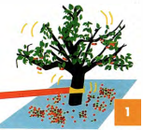 |  | 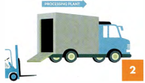 |  | 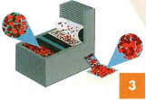
  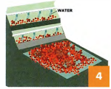 | 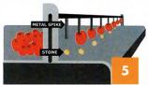 |  | 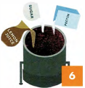 |  | 
  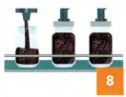 | 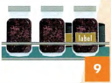
  add | check | collect | cook | put | remove
  shake | spread | stick | take | wash | transport
[[[[[[[[[EXAM SKILLS]
 | The pictures show the process of making cherry jam. Describe the process.  Describe the process.  Remember to:  - include an introduction and an overview  - use the present simple passive  - use sequencing expressions  - write 150 words.  Sample answer  The pictures show the stages in the production of cherry jam. There are a number of processes involved, from picking the fruit from the tree to putting it into jars ready to sell.  First, a sheet is spread on the ground under the tree and the tree is shaken by a mechanical arm to get the cherries down from the tree. Then, the cherries are collected and transported by lorry to the processing plant. There the leaves and the stems are removed and then the stone is taken out with a metal spike. Next, sugar, lemon juice and pectin are added to the cherries and the jam is cooked. After that, the quality of the jam is checked and then the jam is put into jars. A lid is put on top of the jars to keep the jam fresh. Finally, a label is added and the jam is ready to be sold in the shops. | TIP 11
  11
  Use the words on the pictures and diagrams in your answer. They are given to help you.

UNIT/01: RELATIONSHIPS
LISTENING
IN THIS unIT YOU WILL
LEARN HOW TO
- identify the speakers in a conversation.
- listen for numbers
- answer multiple-choice questions.

Lead-in
 | In Section 1 of the Listening test you will hear two people talking in everyday situations. Tick TWO situations that could be in Section 1 of the Listening test.  C, D  - Discussing a course assignment  - Describing changes in family life over time  - Choosing a gift  - Arranging a birthday celebration
  01
 | Listen and match the conversations with two of the situations above.  02  Conversation 1: D Conversation 2: C
  02

IDENTIFYING THE SPEAKERS

 | Listen to the conversations again and pay attention to the speakers. For questions 1-4, write M for male and F for female next to the people.  02
  03
   | Male or female? | Information wanted
  Conversation 1 | manager 1 M  customer 2 F | - The customer would like to ---  - book a table.  - order a meal.
  Conversation 2 | shop assistant 3 F  customer 4 M | - The customer wants to buy ---  - a necklace.  - earrings.
  ◉ In Section 1 of the Listening test you will hear two speakers. In Section 3, there will be two or three speakers. In each case the speakers' voices will sound different from each other to help you easily identify who is speaking. The answers could be given by any of the speakers. In Section 1, there is normally one person who has to find out information from the other.
 | Listen again and for questions 5 and 6, choose the correct answer, A or B.  - A  - B  02
  04

LISTENING FOR NUMBERS

 | Listen and circle the number you hear in each pair.  03  Listen and circle the number you hear in each pair.
  05
  - 1st/3rd  3rd  - $ 10.5 /$10.15  $ 10.5  - 6th/5th  6th  - 17/70  70 | - 19/90  19  - 52/62  62  - £110/£810  £110  - 22nd/27th  27th
  ◉ In Section 1 of the Listening test you need to listen for specific details. These details often include numbers.
 | Listen to the next part of conversation 1 and choose the correct answer.  04  - How many people does the woman want to make the booking for?  B  - What is the date of the booking?  C  TIP 06
  06
  - 8 | - 12 | - 16
  - 12th | - 16th | - 17th
  You will usually hear all the numbers given in the options but only one will be correct. It is important to listen carefully for key phrases, so that you can choose the correct one.
 | Look at the following phrases taken from the recording.  What number is missing?  - No, no, it's the day after – the ---.  16th/17th  17th  - The private room can seat up to --- people.  12/20  20
  07
 | Now listen to the rest of conversation 1 and choose the correct answer.  05  How much is the total cost of the booking?  B
  08
  - £218 | - £318 | - £380
 | Listen to the second part of conversation 2 and answer the questions.  06  - The price of the earrings now is ---  B  - How much does the customer pay for the gift wrapping?  B
  09
  - £10 | - £20 | - £30
  - £4 | - £5 | - £7
 | Listen again and complete this part of the conversation.  07
  10
  Customer | Oh, really? So, how much are they?
  Assistant | Well, they were 1 30 / thirty moment, so they're a little cheaper - only 2 20 / twenty pounds, but actually we've got a sale on at the pounds. So you can save 3 10 / ten pounds!

[[[[[[[[[[MULTIPLE-CHOICE QUESTIONS]
◉ In multiple-choice tasks, you choose the correct answer from three options, A, Bor C.
There are two types of multiple-choice question:
- a question followed by three possible options
- an unfinished statement followed by three possible endings

 | Match the words and phrases 1-5 to words and phrases a-e, which have a similar meaning. | TIP 11
  11
  - a goodbye party  c  - a soccer game  e  - a celebration  d  - brother and sister  a  - work in the same office  b | - members of the same family  - colleagues  - a leaving party  - a birthday party  - a football match
  The words in the questions and options (A, B, C) may not be the same as the words you hear on the recording. You need to listen for words with a similar meaning. It can sometimes help to rephrase the question in your own words before you listen.
 | Read questions 1-6 in the Exam skills task below and match them with the topic areas in the box.  - The relationship between the people  - The type of event  - Colour  - The meaning of something  - Food  - Presents
  12
  Colour | Food | Presents | The meaning of something
  The relationship between the people |  |  | The type of event
[[[[[[[[[[EXAM SKILLS]

 | Listen to the conversation and choose the correct letter, A, B or C.  08 | TIP 13
  13
  - Who are the two speakers?  A  - good friends  - work colleagues  - family members | - The purse represents  B  - good health.  - good fortune.  - wealth.
  - Who are the two speakers?  A  - good friends  - work colleagues  - family members | - What food do guests  C  - good health.  - good fortune.  - wealth.
  - Who are the two speakers?  C  - good friends  - work colleagues  - family members | - The purse represents  B  - good health.  - good fortune.  - wealth.
  Use the questions to help you to follow the recording. Multiple-choice questions are in the same order as the information in the recording. You will hear the answer to question 2 before you hear the information which gives you the answer to question 3.

UNIT/01: RELATIONSHIPS
SPEAKING
IN THIS unIT YOU WILL
LEARN HOW TO
- use simple adjective-noun collocations relating to family
- answer simple questions about your family
- give full answers to Part 1 questions.

Lead-in

 | Talk to a partner about these members of your family for 20 seconds each. Try to keep talking for the full 20 seconds.  Example: sister My sister is my parents' daughter I other daughter.
  01
  father | mother | brother | grandmother | grandfather

USING ADJECTIVES AND NOUNS TO DESCRIBE YOUR FAMILY

 | Listen to Hoi Chin talking about her family and read the first part of what she says. Which collocations does she use to describe her family?  (not) a large family, a small family, a typical family, a close, happy family  09 | TIP 02
  02
  Examiner | Let's talk about family. So, tell me about your family
  Hoi Chin | My family? Well, my family isn't a large family. It's quite a small family1 in fact - and quite a typical family for my country. Just my parents, my older brother and me. So, I'm the baby of the family! I think we're a close, happy family. We do a lot of things together, particularly preparing food - and eating it of course!
  ◉ Many words in English often 'go together' with other words. This is called 'collocation'. For example, we say a fast car, but we don't say a quick car.
  It is a good idea to use collocations in the Speaking test. This shows the examiner that you have a good vocabulary.
 | Which adjective in the box can you NOT use in this sentence?  You can't say 'a best family'. | TIP 03
  03
  We are a family.
    best | close | happy
    large | small | typical
  With a partner, describe your family using the collocations in the box.
  It is a good idea to make a list of useful words and add to the list as you meet new words when you read and listen, and also to write down words which go together.
  You may want to group words under headings to help you remember them.

GRAMMAR FOCUS: ADVERBS OF FREQUENCY
SOMETIMES, OFTEN, NEVER, RARELY AND ALWAYS

 | Listen to a candidate talking about the things he does with his family. Answer the questions.  10  - How often does he go out with his family?  once a week  - What days of the week does he go out with his family?  on Saturdays or Sundays/ at weekends  - Where do they often go?  to the beach  - What do they usually do when they get to the park?  They usually go for a long walk.  - Who sometimes comes with them?  His cousin sometimes comes with them.
  04
 | With a partner, use the questions above to discuss how often you do these things with your family.
  05
  eat out | go bowling | go to the cinema

[[[[[[[[[[ANSWERING PART 1 QUESTIONS]

 | Listen to Hoi Chin talking about her family and read the first part of what she says. Which collocations does she use to describe her family?  - asks you about your likes and dislikes?  c  - asks you about your personal preferences?  d  - asks you how regularly you do something?  b  - asks you to talk about who you are like in your family?  a  - Are you more similar to your mother or your father?  - How often do you go out with your family?  - What do you enjoy doing with your family?  - Do you prefer spending time with your family or your friends?  Now, ask and answer these questions with a partner. | TIP 06
  06
  ◉ In Part 1 of the Speaking test the examiner will ask you a few questions about yourself, for example about your family, your likes and dislikes, where you live.
  It is important to listen carefully to the questions that the examiner uses. Make sure you answer the question that is asked.
 | Listen again to Hoi Chin talking about her family and giving more information. Complete the notes below.  11  - Her parents and 1 older der brother  - They are a 2 close happy family.  - They like preparing food and 3 eating it.  - Her father is a better 4 cook than her mother.  - Her brother is getting 5 married next year.  - Hoi Chin would like to have a 6 niece or 7 nephew one day.  Tell your partner what you remember about Hoi Chin's family. Is your family similar or very different to hers?
  07

EXTENDING YOUR ANSWERS IN SPEAKING PART 1

 | Listen to three students answering the question Who are you most similar to in your family?  12  - Which student's answer was too short?  Student B  - Which student didn't answer the question?  Student A  - Which student's answer was the best?  Student C | TIP 08  TIP 08
  08
  ◉ You can add information to your answer by adding a reason, extra details or combining information:
  I don't see my grandparents very often because they live in the north of the country.
  I don't see my family very often but I miss them very much.
  I have a twin brother, so I am very close to him.
  I look very much like my father, although we have very different personalities.
  In Speaking Part 1:
  - keep to the topic
  - extend your answers
  - don't speak too much
  - do not try to memorise answers to questions.
  In Part 1 you need to give full answers to the questions, but don't talk for too long. Three sentences is plenty. You have chances to speak for longer in Parts 2 and 3.
 | Use one of the words in the box to help you complete the sentences with ideas of your own. Try to use a different word from the box in each sentence.  Sample answers, but many others are possible  - … because they are the most important people in my life.  - … but we still get along very well.  - … and she is going to move to a different city with her husband.  - … so I don't spend as much time with him as I want to. 4  - … even though he is quite a bit older.  - I visit my parents every weekend ...  - We have a large family...  - My sister is getting married next year...  - My father works very long hours, ...  My brother likes the same things as me,
  09
  also | And | because | but | so | even though

PRONUNCIATION

 | What is the third person singular form of the words in the box?  Example: have - has She has a small family  Listen to the words and group them under /z/, /s/ or /ɪz/ according to how the end is pronounced.  13  /s/: asks, keeps, talks, wants  /z/: enjoys, plays  /ɪz/: chooses, watches | TIP 02
  10
  ask | choose | enjoy | keep | play | talk | want | watch
  ◉ Many words in English often 'go together' with other words. This is called 'collocation'. For example, we say a fast car, but we don't say a quick car.
  It is a good idea to use collocations in the Speaking test. This shows the examiner that you have a good vocabulary.
 | Listen and repeat the sentences. Be careful of the pronunciation of verbs with 's' endings.  Example: have - has She has a small family  13  Is there anyone in your family who annoys you sometimes?  - My father watches football on TV and shouts a lot.  - My brother plays on the computer all the time.  - My mother keeps telling me to tidy my room.
  11
 | With a partner, ask and answer the following questions.  - What activities do different members of your family enjoy doing?  My father enjoys mending old cars. My mother enjoys running and reading books.  - What do your mother and father want you to do in the future?  - What type of films do different members of your family watch?  - What do different members of your family talk to you about?
  12
[[[[[[[[[[EXAM SKILLS]

 | With a partner, ask and answer the questions below about your family. Try to talk for about 20 seconds for each question.  - Do you come from a large family?  - Is there anything you usually do together with your family?  - How often do you see your grandparents?  - Who do you like the most in your family?  - Would you like to spend more time with your family?  When your partner is speaking, make notes about any interesting vocabulary (particularly collocations} that you hear. Then, ask and answer the questions again.
  13

UNIT/02: PLACES AND BUILDINGS
READING
IN THIS unIT YOU WILL
LEARN HOW TO
- respond to sentence completion questions
- skim read a text
- recognise paraphrase
- practise using the present simple and past simple.

Lead-in

 | Tell your partner about the house or apartment you live in.
  01
  Is it big or | How many bedrooms | Is it old or | Does it have a

 | What kind of house would you like to live in?
  02
  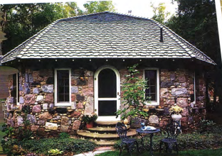  a house in the country | 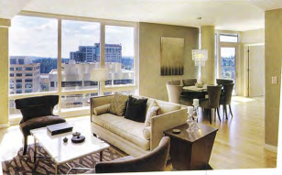  a luxury apartment in the city
  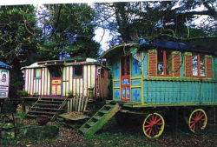
  a caravan

 | Find these in the pictures on this page.  Which ones would you like to live in?
  03
  igloo | treehouse | houseboat | shipping container homes
  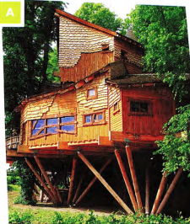 | 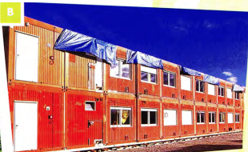
  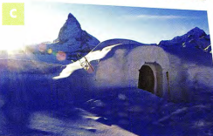 | 
SKIMMING AND SCANNING A TEXT

◉ The skills of skimming and scanning are very important in the Reading test.
Skimming is reading the passage quickly to get an idea of what it is about.
Scanning is also reading the passage quickly, but this time looking for particular information in the text, for example, the answer to a question.
- Before you look at the questions, read through the passage quickly. Don't spend more than a minute on this.
- Skim over (don't spend time on) words like the, they, our, through.
- Notice the 'content' words, such as nouns and verbs, to get an idea of what the passage is about.
- Read the questions.
- Scan the passage for the answers. Let your eyes move quickly over the text until you see one of the key words from the question, or words that have a similar meaning.
- Read that part of the passage carefully until you find the answer.

 | What is the passage about? Read it in ONE minute and choose one of the options.  - Life in different cities around the world  - Unusual places to live or stay around the world  The type of houses and flats most people live in
  04
 | Read the passage again to find the words from the box in exercise 3 as quickly as you can.
  05
 | Which of the two activities you have just done practised scanning? Which practised skimming?
  06
  AMAZING HOMES
  Most people live in a house or a flat. When they go on holiday they stay in a hotel or a guest house. But some places where you can live or stay are a bit different.
  - One unusual place to live is a houseboat. Amsterdam in Holland is famous for its houseboats - there are about 2,500 of them. They have everything that a normal house has: a living room, bedroom, kitchen, bathroom and even sometimes a terrace on the roof. They are cheaper than houses and people who live on houseboats enjoy being close to nature. Some houseboats can be moved to other parts of the river, while others are permanently in one place.
  - In Tokyo, Japan, there is a see-through house. It is like a normal Japanese house but all the walls are made of glass. There is plenty of daylight but no privacy. Architect Sou Fujimoto designed it for a couple to make their home. He based his ideas on early man living in trees. It wouldn't suit everyone but the couple who live there love the feeling of being surrounded by the natural world.
  - All around the world, people live in homes made from shipping containers. Some use only one container, while others are made from several containers joined together. One house in Chile was built from 12 containers. They are cheap to buy and eco-friendly. They can also be placed in the garden or drive as guest rooms, studies or utility rooms.
  - in Germany, you can stay in a one-metre-square house, the smallest house in the world, called the House NA. Van Bo Le-Mentzel, a refugee from Laos, built it to draw attention to the world housing shortage. It is a wooden structure on wheels and weighs 40 kg. It has a locking door and a window. You can turn it onto its side when you want to lie down. Franz from Munich spent the night in one recently 'just to see what it was like'. He found it a bit uncomfortable!
  - For an unusual holiday you can stay in an igloo, a house made of ice. These can be found in several countries including Sweden, Norway and Finland. They are built new every winter. Jenny and Callum, visitors from Australia, told us, 'We slept in an igloo last night. It's so cold here - minus 5 degrees centigrade. We used reindeer skins to keep warm!"
  - Another couple, Shaun and Rachel from Manchester, enjoyed a recent holiday in a treehouse in Sussex, England. They said, 'It was right up in the trees and had everything we needed, even wifi! It had a small kitchen and we did our own cooking. It was the perfect place to get away from our busy lives.

UNDERSTANDING PARAPHRASE

◉ In the Reading paper, it is very important to be able to understand paraphrase (when the same idea is given using different words). The words used in the questions won't be exactly the same as the ones in the passage.

 | Match these words and phrases from the text (1-6) with their paraphrases (a-f).
  07
  - houseboats  - permanently  - privacy  - surrounded by the natural world  - uncomfortable  - Sweden, Norway and Finland | - not being watched by others  - not feeling pleasant  - homes on the water  - Nordic countries  - forever, always  - having nature all around
 | Choose the best paraphrase for these sentences from the text.  - The treehouse had everything we needed.  - We needed some more things for our stay in the treehouse.  - The treehouse was very well equipped.  - We need everything for the treehouse.  - Some houseboats can be moved to other parts of the river.  - Not all houseboats are permanently fixed in one place.  - Only some parts of the river have houseboats.  - You can move to a houseboat in another part of the river.  - One house in Chile was built from 12 containers.  - There are 12 houses in Chile made from containers.  - 12 containers were used to make one house.  - You need 12 containers to make a house in Chile.
  08

[[[[[[[[[[SENTENCE COMPLETION]

◉ in this task type you will have to complete a sentence with up to three words (or two words and/or a number) taken from the passage. The instructions will tell you how many words you are allowed to use.
Look at this example: Houseboat occupants like living
This is a paraphrase of the following sentence from the passage
People who live on houseboats enjoy being close to nature.
Because you have to use words from the passage in your answer, the answer is close to nature.

 | Follow the steps in the box opposite and complete the sentences.  Choose NO MORE THAN TWO WORDS from the passage for each answer.  - The two people who live in the transparent house love it, but it wouldn't ---.  - The designer of the smallest house hopes to --- to the lack of houses all over the world.  - People who stay in igloos sometimes protect themselves from the cold by making use of ---.  - People who have --- would find a holiday in a treehouse ideal.
  09
  ◉ How to do sentence completion questions
  - Underline key words from the sentence (houseboat occupants, in the above example).
  - Scan the text for the key words or words that mean something similar (people who live on houseboats has a similar meaning to houseboat occupants).
  - Read the sentences near the key words carefully-like living means the same as enjoy being.
  - Find the words that seem to fit the sentence.
  - Check that the meaning of the sentence matches the meaning of the text.
  - Check the grammar of the completed sentence.
  - Check if the word(s) should be singular or plural.
  - Check that you have used the correct number of words.

GRAMMAR FOCUS: PAST SIMPLE AND PRESENT SIMPLE

 | Answer the questions in exercise 5. Follow the advice in the box.  - Which tenses does the passage use?  - present tenses  - past tenses  - both present and past tenses  - Which tenses are used:  - to describe the houses?  - to describe habit or things that are always true?  - to describe people's experiences on holidays?  - to talk about designing or building the house? | TIP 10
  10
  As part of your first quick look at the passage, identify whether it is written mainly in the past, present or future, and if the tense changes. This may help you understand the passage.
 | Choose the correct verb, present simple or past simple.  - Most people in China live / lived in flats.  - In the UK most houses have / had gardens.  - In 2010, my parents move / moved to Australia.  - Nowadays Sarah usually spends/spent her holidays in cities.  - In the past she prefers / preferred beach holidays.
  11
 | Complete the sentences with the correct form of the verb in brackets.  - Farid now --- (share) a flat with some other students.  - Last year he --- (live) at home with his parents.  - Once I --- (stay) on a campsite next to a lake in Italy.  - My flat --- (have) two balconies.  - In 2014 we --- (move) into our new house.
  12

[[[[[[[[[[EXAM SKILLS]
HOME FROM HOME

I remember feeling the first time I left home that I would never be able to feel at home anywhere but in my home. No other place would have my mum and dad, my annoying little brother and my cat, Tilly. Nowhere would smell like my home - my mum's roast chicken in the oven and the salty, seaweed smell that drifted in from the nearby beach. The sound of seagulls squawking was the sound of home. Nowhere else would I feel comfortable enough to put my feet up under me and gaze into the log fire dreaming of the future.  I was 15 when I first went away from home on a school trip to Germany. My friends were going too, but we would all stay with different families. I was nervous about this. I knew the home I was going to would not be as comfortable as mine, the family would not be as kind, and who knew what the German food would be like? I knew I would spend three weeks, homesick and sad, missing my family back home.  We arrived in Germany late at night after a long journey by coach and boat. I was tired and hungry. We went into the school hall, where the host families were waiting to meet us. I wondered which one would be mine. Would they give me dinner at this time and would I be able to eat the unfamiliar food? Suddenly I heard my name called and the name of my exchange partner, Brigitte Schmitt. A pretty, blonde girl stepped forward, smiling widely. Behind her stood her parents, a pleasant-looking couple who were also smiling. They held out their hands and said, 'Wilkommen in Deutschland. Welcome to Germany." | I spent three happy weeks with the Schmitt family. Brigitte had an elder brother, Hendrik, and a younger sister, Lisa. They had two cats, Ping and Pong, who sat on my lap as I looked into the fire in the evenings. The whole family were kind and welcoming. My room was cosy and warm and looked out onto a forest. The fresh clean smell of the trees and of apples baking in the oven became familiar and comforting, like the smells of home. I learnt in those three weeks that you can feel at home anywhere that people are kind to you.  Later that year, Brigitte came to stay with me in the UK. I gave her my room and moved in with my brother. I cleared space for her clothes and put fresh flowers in a vase by the bed. I asked my mum to make her famous roast chicken and an apple pie to make our guest feel at home. We made a welcome banner and put it up on the front door. I did everything I could to help Brigitte feel at home with us. I now understood the importance of a warm welcome.

 | Read the passage and complete the sentences below. Choose NO MORE THAN THREE WORDS from the passage for each answer.  - The writer's mother often cooks ---.  - She thought the visit to Germany would make her feel ---.  - Brigitte came to pick up the girl with ---.  - The Schmitt family's pets' names are ---.  - From her bedroom the girl could see a ---.  - The girl and her family tried hard to make Brigitte ---.
  13

UNIT/02: PLACES AND BUILDINGS
WRITING
IN THIS unIT YOU WILL
LEARN HOW TO
- describe changes over time as shown on a map
- use prepositions to explain location
- use past tense verb forms (active and passive) to describe change.

Lead-in

 | Which of these facilities do you expect to find on a university campus?
  01
  bank | bus stop | car park | halls of residence
  gym | library | laboratories | lecture theatres
  cafés | post office | tennis courts | recreation area
 | In Sri Lanka, a family meal often includes stringhoppers. To make stringhoppers you need some special equipment. Choose the best description of each piece of equipment.
  02
  Sunnyhills University 1995  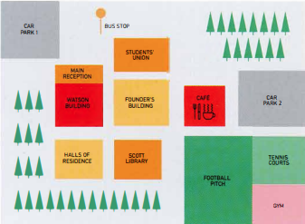  STUDENTS' UNION  MAIN RECEPTION  FOOTBAL PICH | Sunnyhills University today  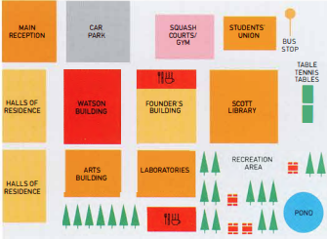  MAIN RECEPTION  SQUASH COURTS/GYM  HALLS OF RESIDENCE  TABLE TENNIS TABLES  LABORATORIESPOND

GRAMMAR FOCUS: PREPOSITIONS OF PLACE

 | Look again at the map of Sunnyhill University campus today. Which of these sentences are true?  - The Founder's Building is between the Watson Building and the Scott Library.  - The bus stop is in the upper right-hand corner of the campus.  - The halls of residence are opposite the Students' Union.  - There are two car parks on the campus.  - There are two places to eat on the campus.  - The main reception is in the middle of the campus.  - The Students' Union moved to a different building between 1995 and today.  - The car park was moved towards the bottom of the campus. | TIP 03
  03
  Prepositions are important in any task including maps. It is important to say exactly where things are located in relation to other places.
 | Complete the sentences about the 1995 campus map using the prepositions in the box.  - The tennis courts were --- the football pitch.  - The Founder's Building was in the middle --- the campus.  - The Scott Library was the halls of residence and the football pitch.  - The cafe was --- the football pitch.  - There were two car parks the campus.  - The gym was the bottom right-hand corner of the campus.  - The Watson Building was the left of the Founder's Building.  - The main reception was part the Watson Building.
  04
  between | in | next to | of | of | on | opposite | to
 | Complete the sentences to describe the map of the campus today to your partner. You can use the expressions in the box.  - The halls of residence ---  - The laboratories ---  - The bus stop ---  - The recreation area ---  - The table tennis tables ---  - The Students' Union ---
  05
  between | in front of | in the top right-hand corner
  next to | on the left | opposite

[[[[[[[[[[DESCRIBING CHANGES IN A MAP]
 | Read this Writing Part 1 task.  You should spend 20 minutes on this task.  Look at the two maps of Sunnyhills University campus in 1995 and today.  Summarise the information by selecting and reporting the main features, and make comparisons where relevant.  You should write at least 150 words.
  06
 |  | There are three important parts in a Part 1 essay. Match the parts 1-3 with their meanings a-c. Then find them in the model answer.  - The introductory sentence  - The concluding sentence  - The overview  - A summary of the main points  - A description of what the data shows  - Writing the most important points again in different words | MODEL ANSWER
  07
  The two maps show changes to the campus of Sunnyhills University between 1995 and today. We can see that the university made many changes during this period, including new buildings and recreation facilities.
  In the past, the Scott Library was in front of the Founder's Building. It was relocated to the right, and in addition, it increased in size. The old library building now contains laboratories. In 1995 there was a car park in the top left-hand corner of the campus, whereas now the main reception is there. The halls of residence were moved to the far left of the campus and a new Arts Building was built opposite them.
  The old sports ground, gym and tennis courts were demolished; however, in their place the university created a new recreation area with a pond, trees and seating areas. What is more, the university developed new sports facilities, including table tennis tables, a new gym and squash courts. They also built two new cafes.
  So, it is clear that the university changed and expanded during this period.

VOCABULARY

 | Find these in the model answer:  - verbs describing change  - expressions describing where things are
  08
 | The underlined words in the model answer are useful for any essay. Among them, find two expressions which:  - mean 'and'  - mean 'but'  - refer to time  - refer to what you see in the chart or diagram | TIP 09
  09
  It is important to use plenty of different words in the essay to show you have a wide vocabulary. Make a list of similar words in your notebook and try to use them when writing your practice essays.
 | Find words in the model answer with these meanings.  - moved to a different place  - made (2 words)  - knocked down  - got bigger (2 words)
  10

GRAMMAR FOCUS: PAST SIMPLE - REGULAR AND IRREGULAR FORMS

 | Find these past tense forms in the model answer. Which of them are irregular? What are the infinitives of these verbs?
  11
  expanded | changed | changed | made | built
  increased | developed | moved | was
 | These sentences could also be used to describe the maps. Put the verb in brackets into the past tense to complete the sentences.  - They (cut) down trees to build the halls of residence.  - The old café (become) the new library.  - In 1995 students (catch) the bus outside the Students' Union.  - The university (need) laboratories.  - They (put) table tennis tables in front of the Scott Library.  - There (be) not enough halls of residence in 1995.  - They (dig) a pond in the recreation area.  - They (plant) lots of new trees.  Two of the verbs are regular. Which ones?
  12

GRAMMAR FOCUS: PAST SIMPLE - ACTIVE AND PASSIVE

 | Read the information about active and passive verbs.  Are sentences 1-4 about the map active or passive?  - The library was relocated to the right of the Founder's Building.  - They also built two new cafés.  - The university created a new recreation area.  - The old gym and tennis courts were demolished.
  13
  ◉ The university developed the campus during this period. - active
  - The subject (the university) did the action.
  - The verb is a single word (developed).
  New halls of residence were built. - passive
  - The subject (new halls of residence) didn't do the action (build), but someone else did the action to it.
  - The verb consists of two words: the correct form of be (were) + past participle (built).
 | Change these sentences from active to passive.  - The university expanded the campus. The campus was expanded.  - They planted trees in the recreation area.  - The authorities moved the bus stop.  - They built a new main reception.
  14

[[[[[[[[[EXAM SKILLS]
 | Answer the task below. Take as much time as you need and try to write 150 words.  The verbs in the box may be useful. Check the meaning of any unknown words.  Remember to:  - write an introductory sentence  - include an overview  - use the present simple and past simple, both active and passive  - use prepositions to explain where things are/were.
  15
  add | build | construct | create | develop | expand | move | plant trees
  The maps below show Colwick Arts Centre in 2005 and today.
  Summarise the information by selecting and reporting the main features, and make comparisons where relevant.
  2005  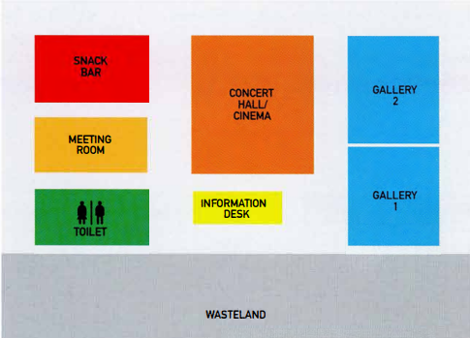  SNACK BAR  MEETING ROOM  TOILET  CONCERT HALL/CINEMA  INFORMATION DESK  GALLERY  WASTELAND | Today  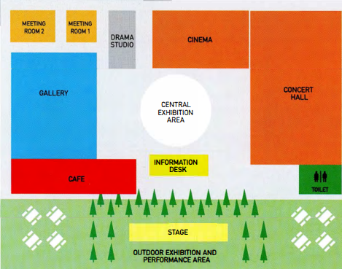  MEETING ROOM  DRAMA STUDIO  CINEMA  CENTRAL EXHIBITION AREA  CONCERT HALL  STAGE  OUTDOOR EXHIBITION AND PERFORMANCE AREA

UNIT/02: PLACES AND BUILDINGS
LISTENING
IN THIS unIT YOU WILL
LEARN HOW TO
- answer short-answer questions
- spell names correctly.

Lead-in
 | Here are some pictures of places in a town. Match pictures A-G with the words in the box.
  01
  railway station | museum | bank | harbour
  sports centre | restaurant | bus stop
   |  |  |  |  | 
   |  |  |  | 
 | Put the words in exercise 1 into the correct group. There is an example to help you.  Travel and transport: harbour, ---. ---  Sports and leisure:---, ---  Arts and culture: ---  Money: ---
  02
 | Put the words in exercise 1 into the correct group. There is an example to help you.  15  Conversation 1 ---  Conversation 2 ---
  03

SPELLING NAMES

 | Listen to the rest of conversations 1 and 2 and answer the questions.  16  Conversation 1  - What is the address of the sports website?  Conversation 2  - What is the man's name? James ---  - What is his address? --- Road
  04
  - www.getactive.com | - www.getaktive.com
  ◉ In Section 1 of the Listening test you may have to write the name of a person, a place or a website. Usually the names will be spelled for you. You need to know the letters of the English alphabet so that you can write the words correctly. If you don't, your answer will be wrong. You will hear the spelling once only.
 | Listen again and complete the extracts from the two conversations.  The first letter of each word is given to help you.  17  - 'Get active' - Is that a __ o __ w __ ?  - Is that[ ... ] w __ an 'e' or without?  - It's got an 'e' at the e __ .  - Is that[ ... ] with ad __ 'd', did you say?
  05
[[[[[[[[[[SHORT-ANSWERQUESTIONS]

 | Read the questions and underline the key words.  The first one has been done for you.  - What did the speakers order in the restaurant?  - How much did each person pay for their meal?  - What time is the bus due?  - Where is the bus stop?  - How long did the course last?  - Which TWO things did the speaker do on the course?  - What is the date of the next course?  - Who will lead the course?
  06
  ◉ You often use short answers in note completion tasks. In this type of task you answer questions using up to three words, or two words and/or a number.
 | Complete the table. Use the key words in the questions in exercise 6 to help you. The first one has been done for you.
  07
  Which questions need ••• | Question
  - a date  - a price  - a period of time  - a time  - a meal or a kind of food  - a name of a person  - the names of activities or skills  - a place? | 7

 | Look at the table you completed in exercise 7. For which questions do you need to write a number?
  08
 | Listen to the conversation and answer the questions.  Write NO MORE THAN ONE WORD AND/OR A NUMBER for each answer.  18  - What did both speakers order?  - How much did each person pay for the meal? £
  09
 | Read this question about a shopping trip, and choose the correct answer.  Why is the other answer incorrect?  Answer the question. Write NO MORE THAN ONE WORD AND/OR A NUMBER for each answer.  What did the boy buy in the shopping mall?  Answer: shoes / he bought shoes | TIP 10
  10
  It is important to check the instructions carefully to see how many words you can write in your answer.
 | Listen to the conversation and choose the correct answers.  Why are the other answers incorrect?  Answer the questions. Write NO MORE THAN ONE WORD AND/OR A NUMBER for each answer.  19  - What time is the bus due?  seven fifteen / seven fiftty/7.15/7.50 pm  - Where is the bus stop?  Blithe Road / Blith Road / Blythe Road / Blyth Road | TIP 11
  11
  It is important to check your spelling carefully. If you spell the word incorrectly, your answer will be marked wrong. When you need to answer a question with a number, it is easier and quicker to write it as a number rather than writing it in words. And also you are less likely to make a mistake.

 | Listen to Alicia telling a friend about a sailing course and answer the questions.  Write NO MORE THAN ONE WORD AND/OR A NUMBER for each answer.  20  - How long did the sailing course last?  - What was the first thing that Alicia learnt?  - What is the date of the next course?  - Who will lead the next course?
  12

[[[[[[[[[[EXAM SKILLS]

 | Read questions 1-8 below. For which questions do you need to write a number ONLY?
  13
 | Find the key words in questions 1-8 below.
  14
 | Listen and answer questions 1-8.  Then read your answers carefully.  21  - Did you check your spelling?  - Did you write numbers in digit form?  - Did you check that you have written the correct number of words?  Questions 1-5  Answer the questions below. Write NO MORE THAN TWO WORDS AND/OR A NUMBER for each answer.  - 1 What kind of tour did the woman do?  - How did she find out about the tour?  - How many people were on the tour?  - What is the address of the hire shop?  - How much did each student in the group pay? $  Questions 6-7  Which TWO items were included in the cost of the hire?  6  7  Question 8  What is the website address of the hire shop?
  15

UNIT/02: PLACES AND BUILDINGS
SPEAKING
IN THIS unIT YOU WILL
LEARN HOW TO
- use prepositions to talk about your home town
- use adjectives to describe your home town
- use the correct tense when responding to questions
- pronounce regular and irregular past simple tense endings.

Lead-in

 | What tense would you use to answer these questions? Select the correct answer A-C below.  - Is there much for young people to do in your home town?  - What was your home town like in the past?  - Has your home town changed since you were a child?  - Present perfect, e.g. Many things have changed in my home town over the years.  - Present simple, e.g. There are lots of things for young people to do in my home town.  - Past simple, e.g. There were more factories and the houses were smaller.
  01
 | Now, with a partner, ask and answer the three questions in exercise 1.
  02

[[[[[[[[[[ANSWERING PART 1 QUESTIONS]

USING PREPOSITIONS TO DESCRIBE YOUR HOME TOWN

 | Listen to a boy describing his home town and read the script.  Match the places the boy talks about with A - H on the map.  22
  03
  town hall H | library | art gallery | cinema
  shopping mall | harbour | stadium | swimming pool
  Well, I live in a small town in the north of my country. It has quite a few interesting places to visit. For example, in the centre of town, on the north side of the square we have the historic town hall, which was built in 1895. In front of it, there's a beautiful fountain. Opposite the town hall there's the library. Then if you go over the bridge, we have the art gallery, a big modern building, which often has interesting exhibitions. The art gallery is actually between the cinema (to the north) and a big shopping mall, where I often meet up with my friends.  To the south of the town, there's a harbour, where you can take a boat to the islands. And then next to the harbour is the stadium, where people go to watch our local football team. And just behind it is the public swimming pool. It's an outdoor pool-lovely in summer, but very chilly the rest of the year. | 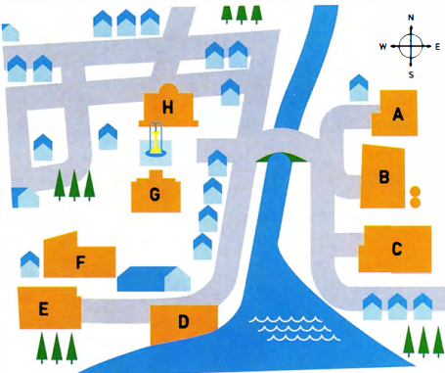
 | Now describe your home town. You might want to draw a map to help you.
  04

USING ADJECTIVES TO DESCRIBE YOUR HOME TOWN

 | Choose the correct heading from the box for the words and phrases in the table below.
  05
  Areas | Buildings | Climate | Location | Opinion
  1 Location | 2 ----- | 3 ----- | 4 ----- | 5 -----
  on the coast  in the north-east  in the centre  outdoor  inland | busy  crowded  dirty  exciting  lively  quiet | hot  humid  mild | industrial  business  financial | tall  historic  ordinary  modern  old

 | Look at the words and phrases in the box and write them in the correct column of the table in exercise 5.  With a partner, add two more adjectives of your own to the table.
  06
  ancient | colourful | cool | enormous | high-rise
  tourist | in the south | indoor | incredible | magnificent
  narrow | polluted | huge
 | Complete the sentences with pairs of adjectives from the table in exercise 5.  - I come from a very modern city. You can see --- and --- buildings everywhere.  - In summer it's very wet and uncomfortable in my town. It's very --- and ---.  - There's usually a light breeze from the sea, so it's very --- and ---.  - There's a lot of rubbish on the streets. It's quite --- and ---.  - There's a great atmosphere in my city, especially at night. It's very ---- and ---. | TIP 07
  07
  It is a good idea to use pairs of words with similar meaning when you talk about your home town.
  This shows the examiner that you have a good range of vocabulary.
  For example: A lot of people live and work in my city. It's very busy and crowded.
 | Look at the photographs below. Try to describe each place using the headings and the words in exercise 5.
  08
  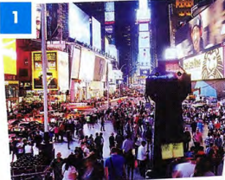 | 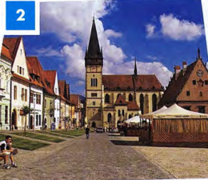 | 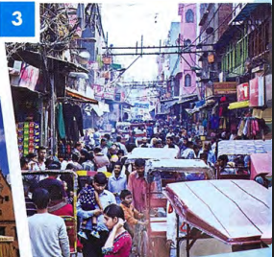

GRAMMAR FOCUS: TENSES

 | Read the questions on the examiner's card.  Then match them with the verb tenses.  Let's talk about the town or city where you grew up.  - Where did you grow up?  - Is it a good place to live?  - Do you think it has changed a lot? How? | TIP 09
  09
  present simple | present perfect | past simple
  ◉ In Part 1 of the Speaking test the examiner will ask you questions about familiar everyday topics such as your home town. To answer the questions you might need to use a range of tenses.
  It is important to listen very carefully to the questions the examiner asks you. This will help you to decide how to form your answer and what tense to use. One thing you can do is repeat or 'echo' the examiner's question to help you do this, but don't do this too often!

 | Read the Part 1 questions from different Speaking tests and choose the correct tense in the candidates' responses.  Listen and check your answers.  23
  11
  Examiner | Where were you born?
  Candidate 1 | I (1) am / was born in Dubai, in the Middle East. It (2) is / was as situated on the north-east coast of the United Arab Emirates.
  Examiner | Where did you grow up?
  Candidate 2 | I (3) am / was born in a small village in China, but I (4) grow up / grew up in Chengdu, which (5) is / was a very big city in south-west China.
  Examiner | Has your home town changed much since you were a child?
  Candidate 3 | In the last ten years Baku (6) changed / has changed a lot. Ten years ago we (7) haven't had / didn't have so many tall buildings and there (8) isn't / wasn't as much to do then. The biggest problem is that everything (9) is / was more expensive now.
  Examiner | Is there anything that you used to do in your home town that you don't do now?
  Candidate 4 | Well, I (10) used to / was used to go to the beach every summer when I (11) have been / was younger, but now I don't have time. One summer, I even (12) used to go/ went fishing. I'd like to do that again. Perhaps I'll have time next summer after my exams.
 | Listen to the sentences and tick the correct column, /t/, /d/ or /ɪd/ according to how the verb ending is pronounced.  24
  12
     | /t/ | /d/ | /ɪd/
    - bought
    - built
    - situated
    - called
    - located
    - changed
     | /t/ | /d/ | /ɪd/
    - developed
    - designed
    - discovered
    - started
    - used to
    - said
  ◉ In the past simple, the ending of the verb can be pronounced in one of three ways: /t/, /d/ and /ɪd/.
  Examples:
  /t/ work-worked
  /d/ play-played
  /ɪd/ decide-decided

 | Complete the sentences with ideas of your own. Then say them to your partner, pronouncing the verb carefully.  - Our family bought --- in the middle of town.  - The --- was built in ---.  - Our town is situated ---.  - The --- is called 'the ---.  - --- is located across from the ---.  - --- have/has changed over the years in my home town.  - --- was/were developed by the harbour.  - --- was designed by ---.  - Recently, scientists discovered --- near our village.  - Recently, many young people have started to ---.  - A long time ago many people used to ---.  - A tourist who visited recently said our town is ---.
  13
 | Read an examiner's questions, then listen to four students answering them. Match the speakers 1-4 with the examiner's questions a-d.  25  - What is your favourite place in your town?  - What do people do for fun in your town?  - Is it easy to travel around your town?  - What is the oldest part of your town?  Speaker 1 --- Speaker 2 ---  Speaker 3 --- Speaker 4 ---  Now ask and answer questions a-d with a partner.
  14
[[[[[[[[[[EXAM SKILLS]

 | Ask and answer the questions below about your home town with a new partner.  Listen to your partner's answers and note any new ideas or vocabulary you hear. Then, ask and answer the questions again and try to improve your answers.  - Can you describe the town where you grew up?  - What places of interest are there in your home town? Where are they?  - Is it a good place for young people? Why?  - Where do young people in your town meet their friends?  - What is your town like at night?  - How has your town changed in the last 10 years?  - Have any new buildings been built?  - A long time ago, where did people from your town used to work?
  15

UNIT/03: EDUCATION AND EMPLOYMENT
READING
IN THIS unIT YOU WILL
LEARN HOW TO
- identify the main ideas of a passage
- find information in a text quickly
- deal with multiple-choice questions.

Lead-in

 | Are these words about work or studies? Put them in the correct column. | TIP 01
  01
  academic | blended learning | business
  degree | employers | retirement
  job | qualification | primary education
  office | lifelong learning | seminars
  Work | Studies
  Divide your vocabulary notebook into topics. Leave space to add new words as you learn them.
 | How many of the words can you find in the text opposite in ONE minute?
  02

[[[[[[[[[[MULTIPLE-CHOICE QUESTIONS]
  FINDING THE ANSWER
   | Spend another ONE minute quickly reading the text and answer this question.  Does the text express a positive or negative view of globalisation in education?
    03
   | Spend another ONE minute quickly reading the text and answer this question.
    04
    - Blended learning means  - continuing to learn throughout your life.  - studying online or via email.  - mixing traditional and modern methods.  - learning in a classroom. | - All of these are advantages of globalised education except  - Students in developing countries can get better jobs.  - Students can get a degree at a cheaper price.  - Universities benefit from international students.  - The elite get most of the opportunities.
  ◉ In multiple-choice questions, you have to choose the correct answer from four options: A, B, C, D.
  In the test, you will not have time to read the whole passage in detail. You need to quickly find the part of the text that contains the answer.
  First, skim the text (read it very quickly) so you know what it is about.
  Next, look at the main part of the questions (NOT the options A, B, C, D) and decide which words will help you find the answer. These are the 'key' words.
  Then, read the text again quickly. This time you are only looking for the key words or words which mean the same. That is the part of the text where the answer is.

GLOBALISATION OF EDUCATION AND THE WORKPLACE
A  Globalisation has affected most aspects of our lives. One area which has changed is education. More and more people move to different countries for their studies. At the same time, more people stay at home and study by distance learning. It is now easy to learn without attending a college or university, or attending less often. 'Blended learning' means studying partly in a traditional way in the classroom and partly online or via email. These changes also mean that there is now more interest in 'lifelong learning', the idea that we go on learning throughout our working lives and even into retirement. It is easy to attend 'webinars' or online seminars without being away from our offices. Many adults go back to college later in life because it is so easy to get a qualification without giving up work or disrupting family life.  B  Different countries have benefitted from the globalisation of education in different ways. Many British, Australian and American universities run their degree programmes in countries throughout Asia, and many students, parents and employers feel this is a valuable opportunity. Students can get an internationally recognised degree at a much cheaper price than going abroad and so can improve their chances of getting a good job. At the same time, those in the countries providing world-class degrees also benefit. They have greater access to ideas and knowledge from all over the world and having international students enriches their universities.  C  However, it is not good news for everyone in some developing countries. It is usually the elite - or the richest people in the large cities - who have access to international education. Many people in rural areas have not even had a primary education. Also, those areas usually do not have reliable internet connections and most people do not own a computer. It will take a bit more time for international opportunities to reach everyone in developing countries. | D  One concern people have about globalisation is that it can start to mean 'westernisation'. In other words, local knowledge can be lost and money seen as more important than culture. Education should treat every culture with respect; it should not be just learning about the West, but should include different ways of teaching and approaches from around the world. The aim is to enrich and share; the flow of ideas and information should go from East to West as well as from West to East.  E  Educational institutions have changed their focus due to globalisation. There are so many benefits of having overseas students that universities are competing for them, using strategies from the world of business. For example, they visit Education Fairs all over the world and spend time and money creating publicity material and advertisements. There is also more emphasis on the student experience. There is more focus on customer care, especially helping international students to settle in, improve their English and understand the academic culture of the host country.  F  There are many advantages to the globalisation of education and the workplace. More people get benefits that were only available to those in the developed countries before. There is more understanding between different nations as people learn about each other's cultures. However, it is important to make sure the benefits reach everyone and don't leave many citizens of the developing world behind.

LOOKING FOR WORDS WITH SIMILAR MEANINGS

 | If you see these words (1-7) in a question, what words might you expect to find in the text? Choose a word or phrase from the box below.  The words you don't need are examples of the type of words which are likely to be the same in both the question and the text.
  05
  - abroad  - benefits  - disturbing  - going to | - make better  - useful  - workplaces
  advantages | attending | distance learning | overseas
  globalisation | enrich | lifelong learning | offices
  Disrupting | valuable | westernisation
  ◉
  - Sometimes the words in the text are the same as the key words in the question, for example the technical term 'blended learning'.
  - Sometimes the words in the text are different to the key words, but they mean something similar.
  - When you are looking for the key words in the text, it is important to look for words, or groups of words, that mean the same. We call these 'paraphrases'.

IDENTIFYING THE MAIN IDEA

 | Which FOUR sentences represent the main ideas of the passage?  - There are both advantages and disadvantages to the globalisation of education.  - Many people study after retirement.  - It is important that globalisation should not be westernisation.  - Universities have had to become more business-focused.  - University fees rose dramatically in the UK in 2012.  - Many poorer people in developing countries do not benefit from globalisation.  - Most lecturers work part-time.  Where in the paragraph can the main ideas be found? | TIP 06
  06
  ◉ Questions often relate to the main ideas of the passage. It is therefore important that you are able to identify them.
  Read the first paragraph and the first sentence of every other paragraph, as this is where the main ideas can usually be found.

MULTIPLE-CHOICE QUESTIONS: ANOTHER WAY TO DO THEM

 | Write your own answers to these questions.  - Who benefits from globalised education in developing countries?  - What is the meaning of 'westernisation'?  - How has the focus of educational institutions changed?  Look at the options and find the one closest to your answer.  - Who benefits from globalised education in developing countries?  - almost everyone in those countries  - mainly well-off people in big towns  - only those in developed countries  - only those who own a computer  - What is the meaning of 'westernisation'?  - learning only about the West  - learning local knowledge  - not learning about culture  - treating culture with respect  - How has the focus of educational institutions changed?  - They have become poor value for money.  - Staff are not committed to their students.  - They are focused on attracting students.  - They only want foreign students.  Then read the passage again and answer the questions. Was it helpful to try to answer the question yourself first? | TIP 06
  07
  ◉ Questions often relate to the main ideas of the passage. It is therefore important that you are able to identify them.
  Read the first paragraph and the first sentence of every other paragraph, as this is where the main ideas can usually be found.

GRAMMAR FOCUS: THE PRESENT PERFECT

 | Look at this example of the present perfect from the first sentence of the passage:  Globalisation has affected most aspects of our lives.  Did this happen in the past or present? -It began in the past.  Does it have results in the present? -Yes. We are still affected by globalisation.  Look at the options and find the one closest to your answer.  - Look at these present perfect sentences from the passage. Do they relate to both the past and the present? How?  - Different countries have benefitted from the globalisation of education in different ways.  - Many people in rural areas have not even had a primary education.  - Educational institutions have changed their focus due to globalisation.  - Which of these tenses is used most in the passage?  - simple past  - simple present  - present continuous  - Choose the best reason for this choice of tense.  - The situation affects people now.  - Most of the changes happened in the past.  - It is a constantly changing situation. | TIP 06
  08
  ◉ Questions often relate to the main ideas of the passage. It is therefore important that you are able to identify them.
  Read the first paragraph and the first sentence of every other paragraph, as this is where the main ideas can usually be found.

[[[[[[[[[[EXAM SKILLS]
 | Read the text on work-based learning and answer the questions that follow.
  09
  ◉
  - Read (skim) the text very quickly so you understand what it is about.
  - Read the main part of the questions and find the key words (the words
  - that will help you find the answer in the passage).
  - Find the key words or words that mean the same in the passage.
  - Try to answer the question without looking at the options A-D.
  - Find the option, A, B, C or D, that matches your answer.
  - Check that the other options are incorrect.

EDUCATION
AND THE WORKPLACE
IN THE UK

A  There has been a trend towards creating a closer connection between education/training and the workplace. This is because many employers felt that school leavers were not prepared well enough and didn't have the skills they would need to do well at work. Having a close relationship between training and work is not new: apprenticeships were a common way of learning in the past. Young people learnt by working with an expert, but this was most common in trades such as builders or electricians. The trend now is for a closer connection between education and the workplace at all levels and in many different types of job.  B  In 1944, the UK government created a new system of education. Education was divided into three parts. Children who passed an exam at 11 went to grammar schools. Pupils who didn't do well in the exam went to 'secondary modern' schools or technical schools. At technical schools they studied work-based subjects. In practice, however, only 0.5% of pupils went to technical schools, and this system divided students at a very young age into academic and non-academic. The system did not produce good results, and changed to a more equal system in the 1970s. B  C  In the 1980s the British government introduced NVQS or National Vocational Qualifications so that young people could get certificates to show their practical skills. It helps employers understand what workers can do. In 1994, the government started a programme which aimed to provide 'quality training on a work-based (educational) route'. These 'modern apprenticeships' are available at three different levels. | D  At the higher levels of education, too, there has been more emphasis on work-based learning, which links academic study closely to practical experience. At degree level, companies have linked with universities to create specialised qualifications, such as the BA in Distribution run between Middlesex University and Asda Supermarket. Such partnerships also exist at Masters and even doctorate level.  development of technology has helped work-based learning to develop. Blended learning means part of the course can be delivered online, so people don't have to miss work to go to classes. Older or recently retired employees have been given the opportunity to develop new skills as tutors, mentors and coaches for the work-based part of these courses. This kind of work-based training was common in fields such as nursing and teaching, but has now spread to careers which were traditionally not closely linked to education.  F  There are some challenges involved in work-based learning. Some lecturers might find it difficult to teach students with a lot of work experience. It may also be difficult to find teachers who can teach in different places and at different times. However, it is a positive trend as there are more ways to learn and people can study at different stages of their lives.

- Apprenticeships  - are a new way of learning.  - were common in the past.  - only existed in the past.  - did not help people do well at work.  - The education system introduced in 1944  - only affected 0.5% of students.  - taught only technical subjects.  - was not a great success.  - was for academically gifted students. | - Blended learning  - mainly benefits older or retired people.  - involves mainly face to face classes.  - is mainly for teaching and nursing.  - is convenient for working people.  - The challenges of work-based learning include  - practical issues like when classes are held.  - students who are not very experienced.  - more types of learning are acceptable.  - older people can't use computers well.

UNIT/03: EDUCATION AND EMPLOYMENT
WRITING
IN THIS unIT YOU WILL
LEARN HOW TO
- describe different types of data
- describe changes in numbers
- use prepositions with numbers.

Lead-in

 | Match the diagrams with their names. Which of them describe changes to numbers over time?
  01
  table | bar chart | pie chart | line graph
  % of graduates in the population (UK)  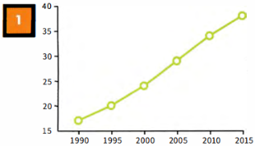 | Which English-speaking country do foreign students want to study in?  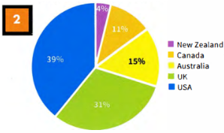
  Participation of 18-year-olds in education and training, 2014  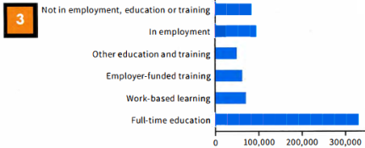  Not in employment, education or training  In employment  Other education and training  Employer-funded training  Work-based learning  Full-time education |  | New entrants to primary teacher training programmes 2007 - present  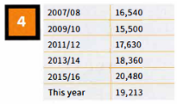

DESCRIBING CHANGES IN NUMBERS

 | Put the words into the correct column. Are they verbs (V), nouns (N) or both?
  02
  decline | decrease | drop | fall | growth | increase | rise
  ↑ | ↓
 | Write the past simple and past participle forms of the verbs.
  03
  infinitive | past simple | past participle
 | Use the correct verb or noun form of one of the words from above to complete the sentences about the table.  New entrants to primary teacher training programmes 2007 - present  - The number of new entrants to primary teaching during _____ the period.  - There was a ____ from 2007/08 to 2009/10.  - There was a steady ___ in numbers from 2009/10 to 2015/16.  - The numbers ___ again this year.
  04
  2007/08 | 16,540
  2007/08 | 16,540
  2009/10 | 15,500
  2011/12 | 17,630
  2013/14 | 18,360
  2015/16 | 20,480
  This year | 19,213

[[[[[[[[[[GRAPHS AND BAR CHARTS]
 | Which is the better description of the line graph: A or B? Why? | TIP 05
  05
  - The graph shows the percentage of graduates in the UK population between 1990 and 2015. In 1990 17% of the population of the UK were graduates. This rose to 20% in 1995 and 24% in 2000. In 2005, it went up to 29%, in 2010 to 34% and up to 38% in 2015.  - The graph shows an upward trend in the % of graduates in the population between 1990 and 2015. The percentage rose gradually throughout the period. It increased by about 3 to 5% every five years, for example between 1990 and 1995 it increased from 17 to 20%. | % of graduates in the population (UK)  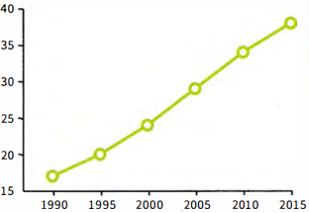
  Select information that is important-don't include everything. You must include some data to support your description.
 | Read sentences 1-9 about the bar chart, and answer the questions.
  05
  - Which TWO sentences should NOT be included? | - Which of the other sentences include the most important information about the bar chart, do you think?
  - There were about 330,000 18-year-olds in full-time education.  - Work-based learning is really useful for young people.  - 60,000 were in employer-funded training.  - Around 70,000 of the age group were involved in work-based learning.  - Only about 50,000 were in the 'other education and training' category.  - There were three times more 18-year-olds in full-time education than in employment.  - The situation is very different in my country.  - About 90,000 were not in employment, education or training.  - More 18-year-olds were in employment than not in employment, education or training. | Participation of 18-year-olds in education and training, 2014  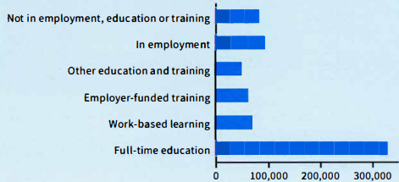  Not in employment, education or training  In employment  Other education and training  Employer-funded training  Work-based learning  Full-time education
 | Complete the sentences with a preposition from the box.  - 17% ___ the population are graduates.  - The number ___ graduates went up.  - It rose ___ 21% ___ 29%.  - It increased ___ about 4%.  - ___ 1992 and 1996 there was an increase.  - There was a rise ___ graduate numbers during the 1990s.
  07
  between | in | from | of | of | to | by

STUDYING A MODEL ANSWER

 | Read the model answer and find:  - the introductory sentence  The diagram demonstrates the process of preparing stringhoppers, a kind of noodle dish.  - the overview  There are six main stages in the process, beginning with grinding the rice and making a dough and ending with using a steamer to cook the stringhoppers.  - a description of data  First, Next, After that, then, The final stage is  - some data to support the descriptions  is put, is mixed, (is) formed, is put, is pushed, are placed, are... cooked  - past simple verb forms  a metal piece of equipment with two handles and holes in it; round baskets made of thin pieces of wood  - a present perfect verb form  grind, rice, dough, steamer, grinder, flour, stringhopper press, stringhopper mats, cook, serve, spicy, curries  in exercise 4  Why is the past simple used more than the present perfect? | MODEL ANSWER
  08
  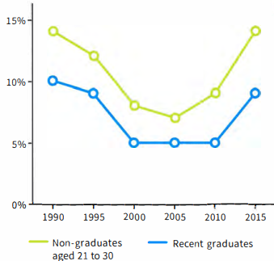
  The line graph shows the number of unemployed recent graduates and non-graduates in the population of 21 to 30-year-olds in the years between 1990 and 2015. Overall, the numbers have not changed much; we can see a fall, followed by a rise, in both groups. The non-graduates are a larger number than the recent graduates at all points.
  Between 1990 and 2000 there was a decrease in the number of unemployed recent graduates and non-graduates. The fall was small from 1990 to 1995, but greater between 1995 and 2000. There was a small change in the middle period. The number of non-graduates dropped and then grew during that period. Over the five years from 2010 to 2015, the numbers of both non-graduates and recent graduates returned almost to their 1990 figures of 14% and 10%.
  Overall, it is clear that having a degree is helpful in finding employment as more non-graduates than recent graduates are out of work.

[[[[[[[[[[DESCRIBING A PIE CHART] | TIP 09
   | Which country matches these phrases?
    09
    - over a third  - a little under a third  - the lowest number of students  - about 1 in 10  - just under a sixth  - the most popular country  - the country in second place  - the least popular country
      Which English-speaking country do foreign students want to study in?
      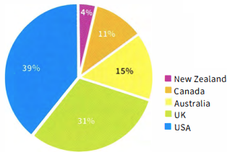
  ◉ In multiple-choice questions, you have to choose the correct answer from four options: A, B, C, D.
  In the test, you will not have time to read the whole passage in detail. You need to quickly find the part of the text that contains the answer.
  Select information that is important-don't include everything. You must include some data to support your description.

[[[[[[[[[EXAM SKILLS]
 | Look at the Writing Part 1 task below. Before you start writing, answer these questions about the graph.  - What are the two groups in green and purple?  - What do the vertical and horizontal axes show?  - Which two regions had the highest literacy rates?  - How many regions show different literacy rates for men and women?  - Which region shows the biggest difference between men and women?  - What are the male and female literacy rates in the least literate region?  - What is the percentage difference between the most and least literate areas?  You should spend about 20 minutes on this task.  The bar chart shows the literacy rate (% of people who can read and write) by region and gender in 2011.  Summarise the information by selecting and reporting the main features, and make comparisons where relevant.  Write at least 150 words.
  10
  Literacy rate by region and gender 2011
  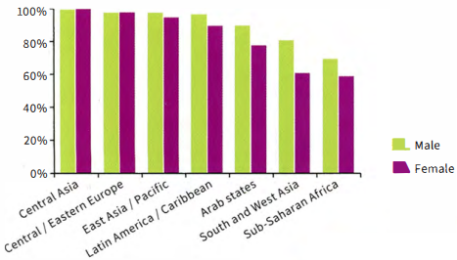
  Central Asia
  Central/Eastern Europe
  East Asia/Pacific
  Latin America/Caribbean
  Arab states
  South and West Asia
  Sub-Saharan Africa
 | Write your answer.  Remember to:  - include introductory and concluding sentences and an overview  - use expressions with prepositions  - use the past simple tense.
  11

UNIT/03: EDUCATION AND EMPLOYMENT
LISTENING
IN THIS unIT YOU WILL
LEARN HOW TO
- identify key words in sentence completion tasks
- use strategies to help you answer sentence completion tasks
- follow a conversation
- recognise synonyms and paraphrase.

Lead-in
 | Pictures A-G show different areas of work or study. Match the pictures with the words in the box.
  01
  hotel and catering | construction | health | sports and leisure
  information technology | art and design | retail
   |  | 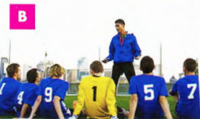 |  | 
  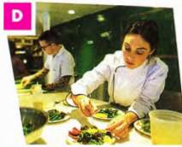 | 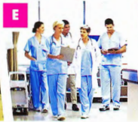 |  | 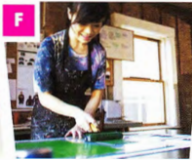 |  | 
  ◉ In the Listening test you may hear people talking about their area of work or studies. And in the Speaking test you may have to talk about your job or your course. It is important to understand and use words related to these topics to help you do this.
 |  | Look at the words in the box. Do they describe a job or a type of course?  Put J for 'job' or C for 'course' next to each word. The first one has been done for you.
  02
  architect J | chef | building engineering | badminton coach
  computing | doctor | fitness training | food technology
  graphic designer | medicine | shop management | store assistant

 | Complete the table. Use the words in exercise 2. There are two examples to help you.
  03
  Job | Area of work or study | Course
  - graphic designer | art and design
   | construction | building engineering
   | health
   | hotel and catering
   | information technology
   | retail
   | sports and leisure
 | Identify the TWO correct endings for each sentence.  - I've done a course in computing/ badminton coach / food technology.  - My sister has worked on a cruise ship as a chef/medicine/doctor.  - Our son had a job as a(n) architect / store assistant/building engineering.  - He's very keen on web designer/fitness training/textiles. | TIP 04
  04
  It is important to listen carefully to the ending of words. For example, words ending in -ology and-tion can be used to talk about different areas of work or study. Words that end in -er may refer to people and jobs.
 | Listen to two short conversations. Are the speakers talking about a job or a course? Put J for 'job' or C for 'course'.  26  Conversation 1 Conversation 2
  05

[[[[[[[[[[SENTENCE COMPLETION] | TIP 06
   | Read the sentences carefully. Underline the key words before and after each gap.  - Anna has got a job as a  - She has recently completed a course in  - The new name of the department which sells computers and phones is  - The Food Photography course takes place on the _______ September.  - There is a total of _______ places available on the course.
    06
  ◉ In this type of task you complete sentences by writing up to three words, or two words and/or a number, in the gaps. The instructions tell you how many words you can write.
  The gaps can come
  - at the beginning of the sentence
  - in the middle of the sentence
  - at the end of the sentence.
  The sentences have a main verb and a subject.
  It is useful to underline the key words in the sentence before you listen to the recording. Doing this will help you decide what kind of information you need to listen for.

 | Match questions 1-5 in exercise 6 with the type of information you need to listen for, given below. The first one has been done for you.  an area of study  a type of job  a number only  a name of a place  a date | TIP 07
  07
  It is important to think about what type of word will go into each gap. This helps you to be ready to hear it during the conversation.
 | Listen again to Anna talking to the store manager and complete the sentences.  Write NO MORE THAN TWO WORDS for each answer.  27  - Anna has got a job as a .  - She has recently completed a course in .  - The new name of the department which sells computers and phones is .
  08

 | Choose the correct grammatical answer. Why are the other answers incorrect?  - Anna has got a job as a assistant/ store assistant.  - She has recently completed a course in informations technology/information technology.  - The new name of the department which sells computers and phones is Moving Image / Moving Images / The Moving Images. | TIP 09
  09
  Take care with singular and plural forms when you write your answers. If you use the wrong form, your answer will be wrong.
 | Listen to the student and the receptionist again and complete the sentences. Write NO MORE THAN ONE WORD AND/OR A NUMBER for each answer.  26  - The course takes place on the ___ September.  - There are a total of _______ places available on the course.  TIP 10
  10
  Pay attention to the number of words you need to write. NO MORE THAN ONE WORD AND/OR A NUMBER means that if you write two words or more, your answer will be wrong. But you can write one word and a number.
  Check to make sure that you have not written 'extra' words that are already in the sentence.
 | Look at the question below and read the answers that different candidates wrote. Which answers are correct? Why are the other answers incorrect?  Complete the sentence below. Write NO MORE THAN ONE WORD AND/OR A NUMBER for your answer.  The course takes place on the September.  Candidates' answers  19  19th  the 19  nineteenth of  19th of September  19 Sept | TIP 11
  11
  You can write numbers in figures or in words. It is a good idea to write them in figures as it takes less time and you will not make any spelling mistakes.

  FOLLOWING A CONVERSATION
   | Read the questions carefully. Then put the topics below in the order they will be mentioned in the conversation. The first one has been done for you.  Complete the sentences below. Write NO MORE THAN TWO WORDS AND/OR A NUMBER for each answer.  - The title of the course the speaker wants to do is ______ _  - The course starts at _______ _  - It lasts for a period of hours in total.  - The course aims to teach people how to use different ______ _  - Part of the course is held at a nearby ______ _  - The total cost of the course is ______ _  - the price of the course  - the location of the course  - the name of the course: 1  - the starting time of the course  - the purpose of the course  - the duration of the course
    12
  ◉ The questions always follow the order of the information you hear in the conversation. This means that you will hear the answer to question 1 before you hear the answer to question 2.

LISTENING FOR SYNONYMS AND PARAPHRASE

◉ The speakers you hear often use different words to those in the questions. You may hear a synonym or paraphrase (a word or words with a similar meaning). Before you listen, try to identify key words and phrases in the sentences and think about possible synonyms for each one.

 | Match the words and phrases 1-9 with their synonyms a-i.
  13
  - price  - name  - duration  - starts  - takes place  - purpose  - ends  - location  - practical | - place  - finishes  - reason for  - is held  - begins  - length  - hands-on  - cost  - title
[[[[[[[[[[EXAM SKILLS]

 | Match the highlighted words in exercise 14 with the words and phrases used on the recording.
  14
  begins | full fee | goes on | it's called
  local | some | train | a range of
 | Listen to the rest of the conversation between the student and the receptionist and complete the sentences. Ignore the highlighted words for now. Write NO MORE THAN TWO WORDS AND/OR A NUMBER for each answer.  - The title of the course the student wants to do is ___  - The course starts at ___ a.m.  - It lasts for a period of ___ hours in total.  - The course aims to teach ___ people how to use different ___.  - Part of the course is held at a nearby ___.  - The total cost of the course is ___.
  15
 | Read your answers to the sentence completion task carefully and then answer the questions in the checklist below.  - Have you answered ALL the questions?  - Have you written the correct number of words in each sentence?  - Have you written numbers as figures to save time?  - Have you checked your spelling?  - Have you checked whether your answer should be in the singular or plural form?  Now check your answers.
  16

UNIT/03: EDUCATION AND EMPLOYMENT
SPEAKING
IN THIS unIT YOU WILL
LEARN HOW TO
- answer simple questions about your work and studies (Speaking Part 1)
- use some strategies to prepare for a talk (Speaking Part 2)
- introduce your talk (Speaking Part 2)
- pronounce words beginning with two consonants.

Lead-in

 | Match photographs A-G with the areas of work and study in the box.
  01
  emergency services | farming | entertainment | education
  science (research and development) |  | travel and transport | tourism
  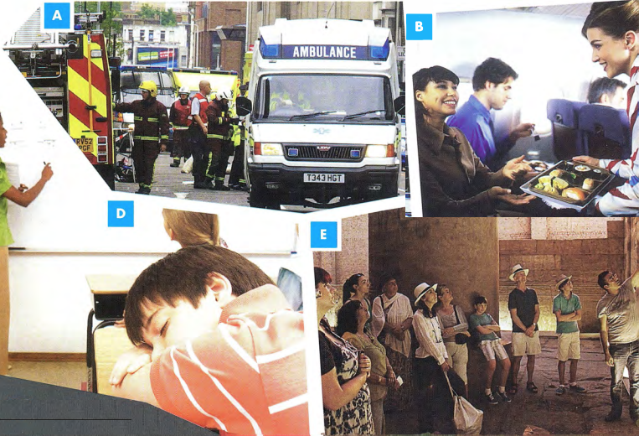
  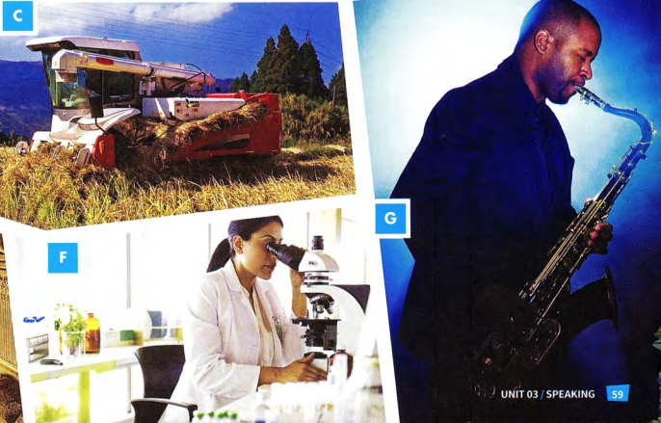

ADJECTIVES TO DESCRIBE FEELINGS AND EXPERIENCES

 | Look at the words in the box. Which words have a negative meaning?
  02
  tired | boring | embarrassed | challenging | fascinated
  great | thrilled | not very exciting | interesting | amazed
 | Read the words in exercise 2 again. Which words can you use to describe your feelings? Which words can you use to describe the experience of doing the things in the photographs? Put F for 'feelings' or E for 'experience' next to each word.  Which ONE word can be used to describe both your feelings and the experience?
  03
 | Complete the table. There is an example to help you.
  04
  I feel/I felt... | It is / It was
  amazed | amazing
   | thrilling
   | boring
   | challenging
  fascinated
  not very excited
   | tiring
   | embarrassing
  interested
  great
 | Choose the correct word in each sentence.  - I've got a place on the course! I'm thrilled / thrilling!  - It's a very interested / interesting job-I'm learning a lot.  - I had to give a presentation in front of my colleagues. I felt really embarrassing / embarrassed.  - She gets boring / bored easily, so she's changed jobs twice.  - He works long hours and late nights and weekends in order to pay for his daughter's university course. It must be very tired / tiring for him.  - She's got an amazing / amazed job. She's a journalist and she's interviewed lots of famous people.
  05

 | Look at photographs A-D and answer the questions.  - Which of these jobs or activities have you done before?  - How did you feel about it?  - Which have you not done yet? Would like to try them? Why?
  06
[[[[[[[[[[SPEAKING TEST - PART 1]
◉The examiner will ask you some simple questions about your work or your studies.
It is important to try to give full answers to the questions and to say what you feel about your job or course of study, Look at the examples of Part 1 questions.
- What do you do? Do you work or are you a student?
- Are you enjoying it?
- Would you like to learn anything new in the future?
- Is there a job you would really like to do in the future?

 | Listen to a recording of Part 1 of the Speaking test. Match the speaker, Nina, with the correct photograph A-D above. Does she work or is she a student?  29
  07
 | Listen again and number the following in the order Nina talks about them.  29  What job she would like to do in the future  How many hours a week she studies/works  What she does  What she would like to learn in the future  What she thinks about her studies/work  Where she studies/works | TIP 07
  08
  It is very important not to simply answer a question with 'Yes' or 'No'. Try to use your imagination and invent some ideas. Remember that the examiner is testing your ability to speak English, not your views or general knowledge. For example, if there isn't a job you would really like to do in future, don't just say 'No'. Think of any job you could talk about.

 | Use the headings in exercise 8 to talk about Anna.
  09
 | Make notes using the headings in exercise 8 to speak about what you do. You may wish to use a dictionary to help you do this.
  10
 | Use your notes to tell your partner about what you do. Ask each other questions.  - What do you do? Do you work or are you a student?  - Are you enjoying it?  - Would you like to learn anything new in the future?  - Is there a job you would really like to do in the future?
  11

PRONUNCIATION: WORDS BEGINNING WITH TWO CONSONANTS

 | Listen and practise the sounds at the beginning of the words in bold.  30  a student-I'm a student.  a scarf - a beautiful scarf  I've just made a beautiful scarf.  plastic - It's made out of plastic.  ate-rate-great  It's great-I think it's great  It looks very strange, but I think it's great!  great close-up shots  I've learnt how to take some great close-up shots!
  12

[[[[[[[[[[SPEAKING TEST - PART 2]
◉In Part 2 of the Speaking test, you prepare and talk about a simple topic.
The topic will be based on your own experience. This means that you should find it familiar and easy to talk about.
You have one minute to prepare your topic.
You must talk for about two minutes.
Part 2 tests your ability to organise your ideas and speak fluently.

 | Read the information about Part 2 and then look at the following topic areas.  Which THREE do you think are Part 2 topic areas?  - Talk about how the education system in your country has changed.  - Talk about a time when you learnt something new.  - Talk about your very first day at school.  - Talk about your ideal place to study.  - Talk about how people normally travel to work in your city.  - Talk about the kind of jobs that people do in your home town.
  13

 | Read the information about Part 2 and then look at the following topic areas.  Which THREE do you think are Part 2 topic areas?  - You talk about the topic in the task, including all four points on the card.  - You stop talking when the examiner tells you to.  - You read a card with a task on it.  - You make notes on each of the separate parts of the task.  - The examiner says, 'Here is your topic card. You now have one minute to prepare your talk."  - The examiner asks you some questions about your talk.
  14
 | Look at the example of a Part 2 card. Highlight or underline the key words in each instruction. The first one has been done for you.  Describe a time when you learnt something new.  You should say:  - what you learnt  - how you learnt it  - what the result was  and explain how you felt about learning something new. | TIP 15
  15
  There are always FOUR instructions on the card, which tell you what you need to talk about. It is therefore important to identify the key words in each instruction. It is important to try to talk about all four points on the card.
 | Before you start your talk, the examiner will give you some paper to make notes on. You need to make sure your notes cover all the points on the card.  Match the key words with the candidate's notes.
  16
  What?  How?  Result?  How I felt? | thrilled and proud of myself  learnt to fly a small plane  had lessons at a flying club  got my pilot's licence

INTRODUCING YOUR TALK

◉It is important that you introduce your talk. Here are some suggestions of ways you can begin.
- I'm going to talk about a time when I learnt something new.
- I'd like to tell you about...
-I want to talk about...

 | Practise introducing the following talks. Say one sentence for each.  - Describe a time when you learnt something new.  - Describe your very first day at school.  - Describe your ideal place to study. | TIP 17
  17
  It is a good idea to introduce your talk clearly and slowly. Doing this gives you time to think about what you are going to say next.

 | Look at the topic card with some student's notes on it. Complete the student's notes by adding notes a-d to the correct part of the card.  Describe a time when you learnt something new.  You should say:  and explain how you felt about learning something new. proud; 4 ___  31 | TIP 18
  18
  - what you learnt  - how you learnt it  - what the result was | learnt to ski; 1 ___  2 ___ , had great instructor!  3 ___ , got a silver cup!
  The points on the topic card often begin with How or Wh-question words such as why, who, when, what or which. These points are given to help you.
 | Make your own notes for the topic card in exercise 18. Use the key words to help you.
  19
 | Practise your talk. Try to speak for two minutes.
  20

